**Microsoft Excel Cheat sheet**

**For a brief overview of Microsoft Office Online Tutorials on learning hub:** <https://learninghub.phsa.ca/Courses/3118/microsoft-office-online-tutorials#info>

**Microsoft Excel Training (Beginner to Excel):**

<https://www.guru99.com/excel-tutorials.html>

**Excel Video Training:**

1. <https://support.microsoft.com/en-us/office/excel-video-training-9bc05390-e94c-46af-a5b3-d7c22f6990bb>
2. <https://www.youtube.com/watch?v=0tdlR1rBwkM>
3. <https://www.youtube.com/watch?v=k1VUZEVuDJ8>

#### Add or Remove Cells, Rows or Columns

Inserting or deleting cells, rows or columns in an Excel is easy with the commands “Insert Cells” and “Delete Cells.” You have to go to the Insert button and select the option you desire.

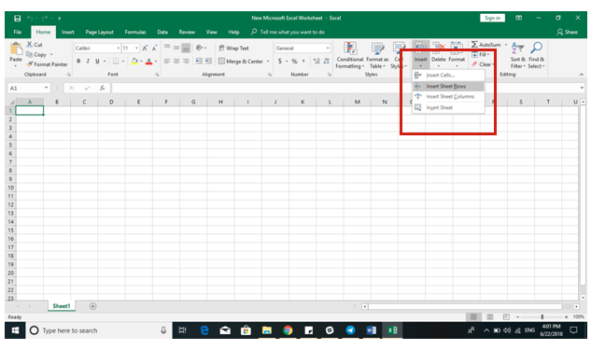

#### Resize Rows and Columns

The size of Excel’s rows and columns is pretty standard, so there’s a fair chance that you will have to adjust their size to accommodate all the data that you need to put in there.

It is relatively simple to change the width or height of a cell by going to the Home icon, clicking on Format and choosing Column Width as the option.

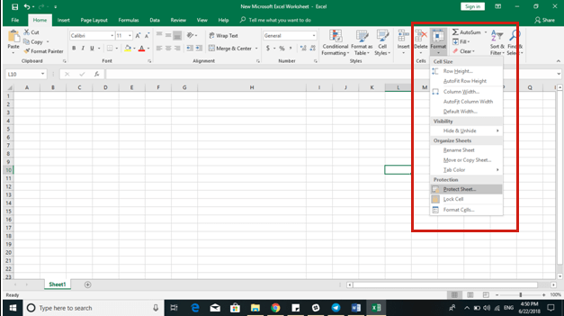

Then, you need to enter the number you’d like the cell to be and click ok.

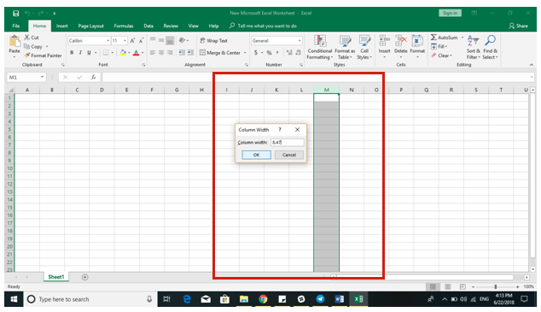

It is also straightforward to manually adjust the rows and columns by placing the pointer anywhere between a row and a column and dragging and expanding the row/column till you reach your desired size.

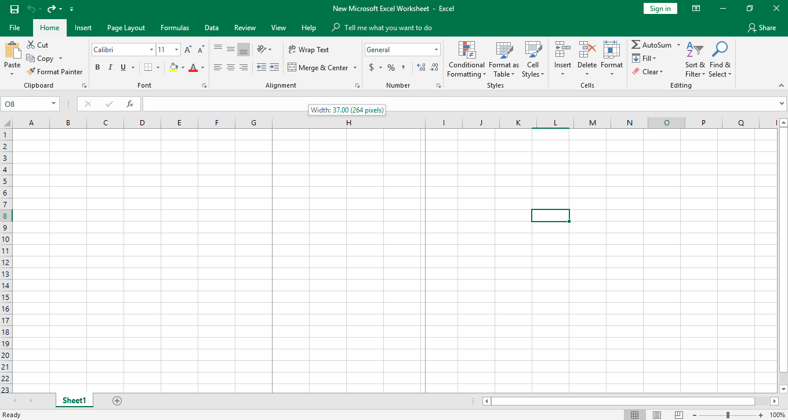

#### Change the Alignment of Text in the Cells

It is easy to use the Format Cells dialogue in the Excel if you wish to create labels or a register so that you can adjust the text alignment in a cell. To apply the formatting, right click on the selected row/column and hit Format Cells.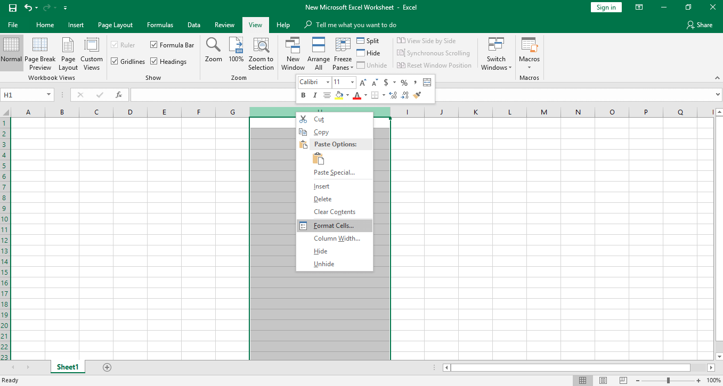

Then choose the Alignment tab, change the text orientation according to your choice and hit ok.

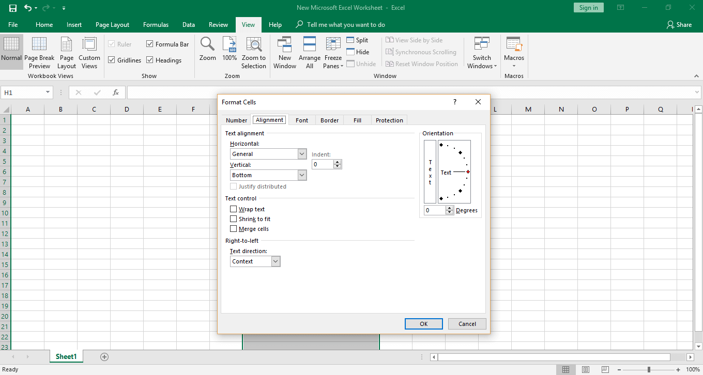

* **Sum** – Calculates the total sum of the selected cells
* **Count** – Counts the number of values in the selected cells leaving empty cells or those that have no numeric data
* **Average** – Calculates the average of the selected cells
* **Min** – Demonstrates the minimum value of the selected cells
* **Max** – Demonstrates the maximum value of the selected cellsTo use a function, go to Home, click on AutoSum, go to the drop-down menu and use the appropriate function you wish to apply to a group of cells. Before doing that, do not forget to select the group of cells you want to implement the function to.

